Phase 4: Process Automation (Admin) — Migrant Health Salesforce Project

This document describes all automations implemented in Phase 4 of the Migrant Health Salesforce project. It includes validation rules, workflow rules, approval processes, record-triggered flows, and screen flows. Each automation has been tested and debugged with detailed steps and troubleshooting notes.

# 1 Validation Rule — Prevent Past Appointment Dates

• Object: Appointment__c

• Rule Name: Prevent_PastDate

• Formula: Appointment_Date__c < TODAY()

• Error Message: Appointment date cannot be in the past.

# 

# 

# 2 Workflow Rule — Welcome Email

• Object: Patient__c

• Rule Name: Patient_Welcome_Email

• Trigger: When record is created

• Criteria: Formula = TRUE

• Action: Send Email Alert → Template with merge fields (Hello {!Patient__c.Name})

• Recipient: Email__c

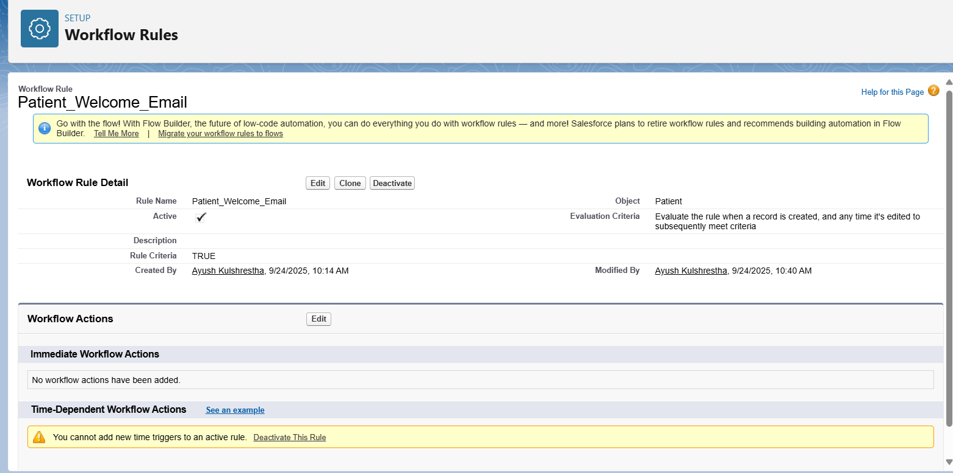

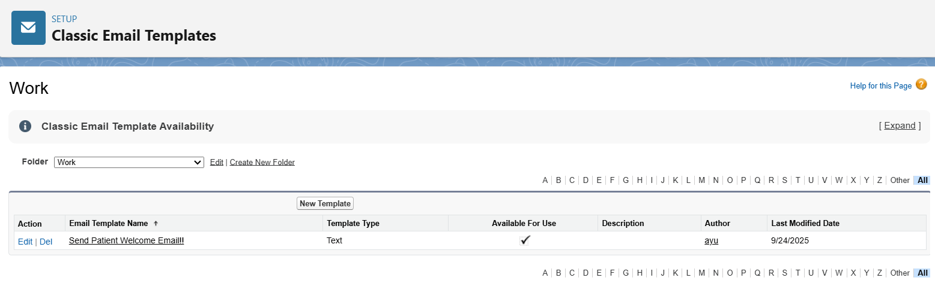

# 3 Workflow Rule — Auto Task for Case Manager

• Object: Patient__c

• Rule Name: Patient_FollowUpTask

• Trigger: When record is created

• Criteria: TRUE

• Action: Create Task → Assigned To = Case_Manager__c, Due Date = Rule Trigger Date + 2 days, Subject = 'Follow up with new patient'.

Troubleshooting: Ensure Case_Manager__c is a Lookup(User). Otherwise, tasks cannot be assigned.

# 

# 4 Approval Process — High Cost Treatments

• Object: Treatment__c

• Name: High Cost Treatment Approval

• Entry Criteria: Estimated_Cost__c > 50000

• Approver: Assigned Salesforce User (simulating Manager)

• Final Actions:

- On Approval → Update Status__c = Approved

- On Rejection → Update Status__c = Rejected

# 

# 5 Flow Builder — Auto Migrant Record

• Object: Appointment__c

• Trigger: When record is updated

• Entry Condition: Status__c = 'Completed'

• Action: Create Migrant_Record_Number__c with:

- Appointment__c = {!$Record.Id}

- Patient__c = {!$Record.Patient__c}

- Status__c = 'Follow-up Pending'

- Notes__c = 'Auto-created on Appointment Completion.'

# 

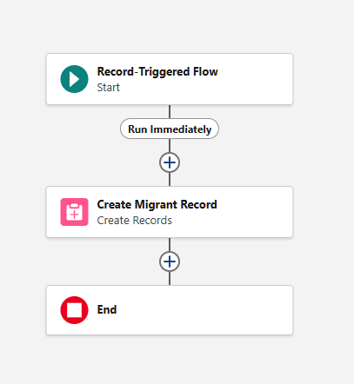

# 

# 6 Screen Flow — Patient Intake

• Flow Type: Screen Flow

• Screen 1: Input fields — Patient Name, Phone, Email, Gender, DOB, Patient ID, 'Create Appointment now?' checkbox

• Create Records: Patient__c

• Optional: Decision → If 'Create Appointment now?' = Yes → Create Appointment__c with Patient__c linked

• Screen 2: Confirmation → 'Patient created successfully — ID: {!var_NewPatientId}'

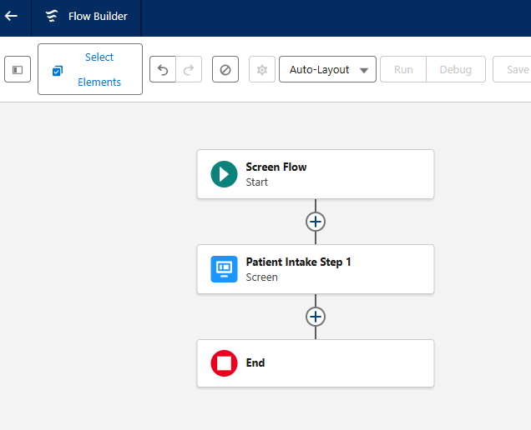

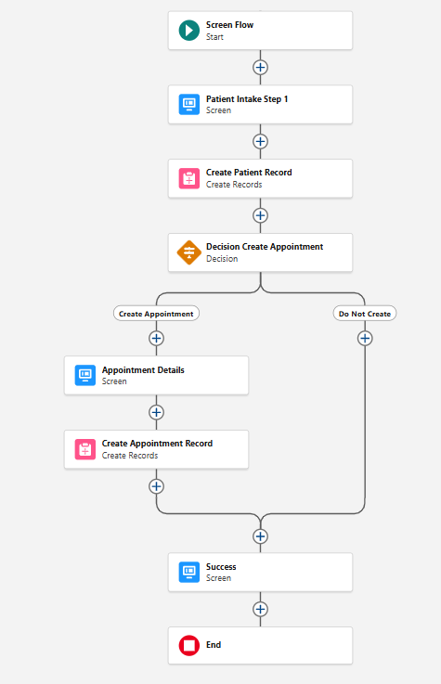

Troubleshooting: Ensure all required fields on Patient__c (e.g., DOB__c, Priority__c) are provided.

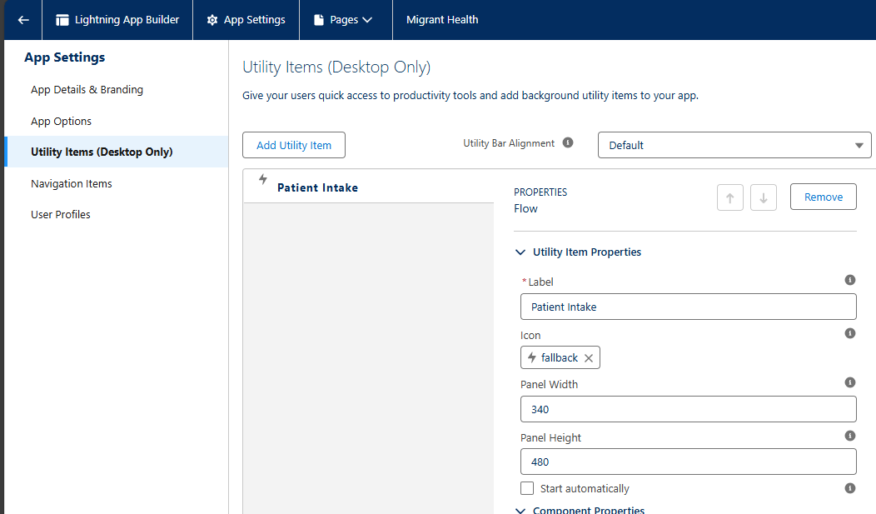

# 7 Testing Instructions

1. Validation Rule → Try creating Appointment with past date → should block with error.

2. Workflow Email → Create new Patient → Welcome Email should be sent.

3. Workflow Task → Create new Patient → Follow-up Task assigned to Case Manager.

4. Approval → Create Treatment with cost > 50,000 → Approval request sent.

5. Auto Migrant Flow → Complete Appointment → Migranst Record auto-created.

6. Screen Flow → Run Patient Intake Flow (App Launcher → Flows) → Patient created and optionally Appointment.